26.13: Current through 2.00- resistor is 6.00 A. Current through 1.00- resistor also is
6.00 A and the voltage is 6.00 V. Voltage across the 6.00- resistor is 12.0 V + 6.0 V = 18.0 V. Current through the 6.00- resistor is 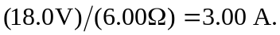 The battery voltage is 18.0 V.

